AI Blognest API — Project Document

1. Brainstorming&Ideation Phase
Concept: An AI-powered API for"Blognest"— an app where users can create, manage, and auto-write blog content using AI.
Core Idea: Mix a normal blog system with AI tools — writing help, summaries, SEO tips, and auto-tags.
Target Users: Bloggers, content writers, small publishing teams, and developers making blog websites.
Key Differences: AI writing help, auto-categorization, content improvement, and analytics — all through a simple REST/GraphQL API.

Possible Features
- AI blog post generator (title, draft, outline)
- Auto SEO tags and keyword suggestions
- Content summarizer for short previews
- Grammar and style suggestions
- Image caption/alt-text generation
- Multi-language translation support

2. Requirement Analysis Phase

Functional Requirements
- Login system with roles (Admin, Author, Editor)
- Create, edit, delete blogs, posts, categories, tags
- AI content generation endpoint (prompt-based)
- AI summary and SEO suggestion endpoints
- Media upload and management
- Search and filter API
- Analytics endpoint (views, engagement)

Non-Functional Requirements
- Scalability (handle many AI requests at once)
- Security (JWT/OAuth2, rate limiting)
- Performance (fast AI response with caching)
- Availability (99.9% uptime target)
Tools/Tech Considered: Node.js/Python backend, PostgreSQL/MongoDB, OpenAI/Claude API, Redis caching, Docker.

3. Project Design Phase
Architecture: Microservice-based — separate services for Core Blog API, AI Service, Auth Service, Media Service.
API Design: RESTful endpoints (or GraphQL schema) with versioning (/api/v1/...).
Security Design: OAuth2/JWT login, role-based access control (RBAC), input checks.

Data Flow Diagram (DFD)
The DFD shows how data moves between the user, the API system, the AI provider, and the stored data — instead of just listing the design points.
Level 0 — Context Diagram
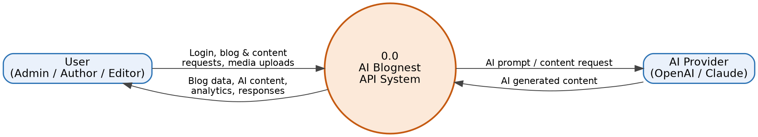
Figure 1: Level 0 DFD — overall data flow between the User, the AI Blognest API System, and the AI Provider.

Level 1 — Detailed DFD
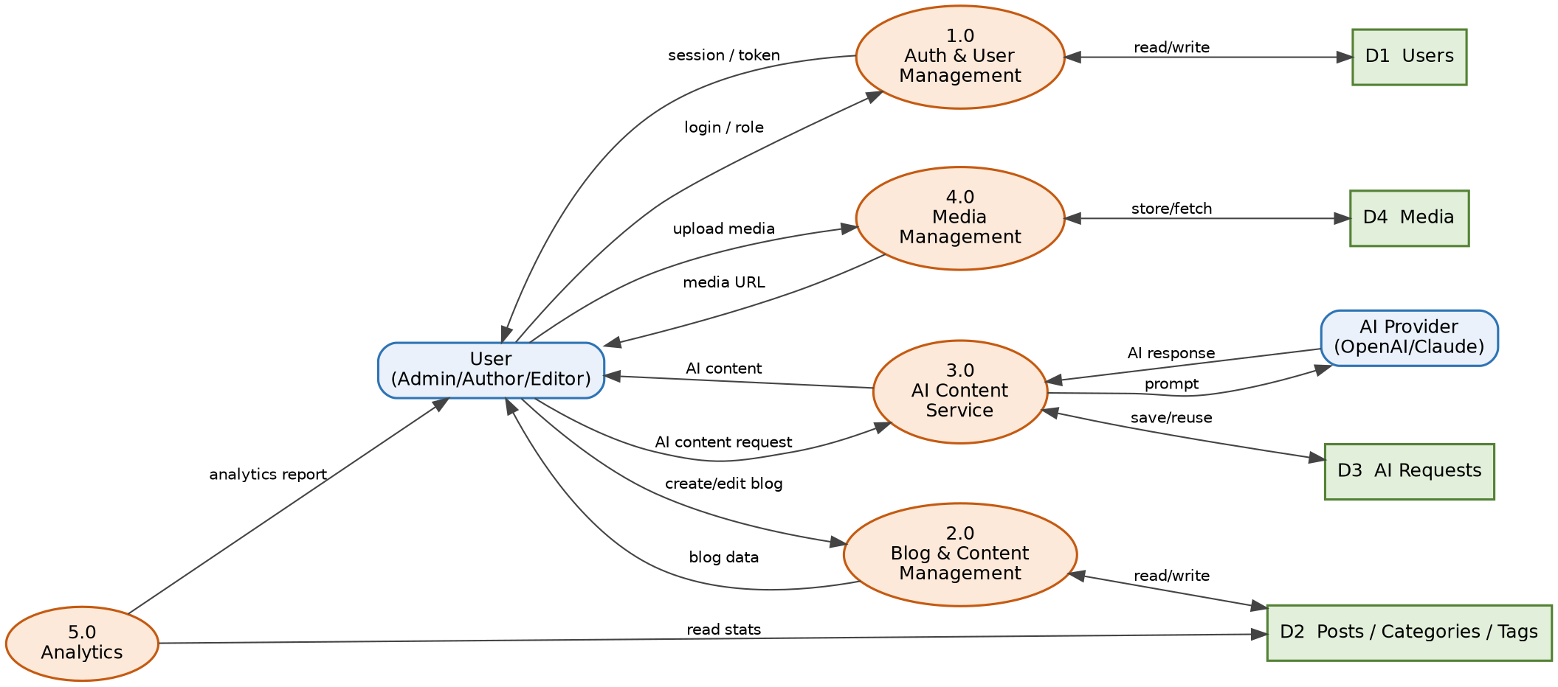
Figure 2: Level 1 DFD — breaks the system into 5 processes and 4 data stores.
- 1.0 Auth&User Management — handles login/roles, reads/writes D1 Users
- 2.0 Blog&Content Management — creates/edits posts, reads/writes D2 Posts/Categories/Tags
- 3.0 AI Content Service — sends prompts to the AI Provider, saves/reuses results in D3 AI Requests
- 4.0 Media Management — uploads/fetches files, reads/writes D4 Media
- 5.0 Analytics — reads D2 to build usage/engagement reports for the User

4. Project Planning Phase
Team Roles: Backend Developer(s), AI/ML Engineer, DevOps, QA Tester, Technical Writer.
Timeline: Sample schedule to be added.
Risk Management: AI API cost/limits, slow response times, data privacy rules.
Tools: Jira/Trello for tracking, GitHub for code, CI/CD pipeline.

5. Project Development Phase
- Set up project repo, environment settings, and CI/CD pipeline
- Build core blog CRUD APIs and login
- Add AI service (prompt writing, API calls, response formatting)
- Build media handling and search/filter
- Add caching for AI responses to save cost/time

6. Project Testing Phase
Unit Testing: Test each endpoint and function on its own.
Integration Testing: Test API + AI service + database together.
Load/Performance Testing: Test with many AI requests at the same time.
Security Testing: Check login bypass, input checks, rate limits.

7. Project Documentation Phase
API Documentation: Swagger/OpenAPI spec for all endpoints.
Technical Documentation: Architecture overview, setup guide, environment variables.
User Guide: How to use the AI content generation features.
Change Log: Version history kept across releases.

8. Project Demonstration Phase
- Prepare a live/recorded demo of key API endpoints (Postman/Swagger UI)
- Show the AI content generation flow start to end
- Share performance numbers and test results
- Collect Q&A / feedback for the next round
This document gives a short, phase-by-phase overview. Each part can be made bigger into its own document as the project moves forward.

